What is the ERN-RND Network?
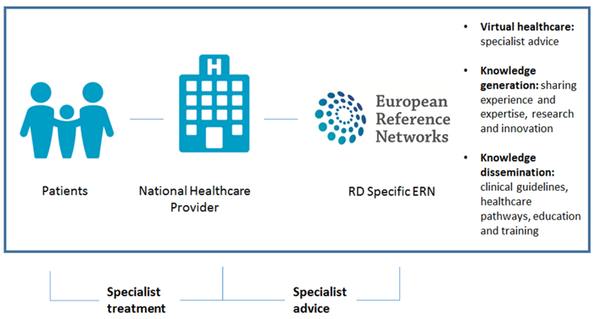

The ERN-RND is a European Reference Network established by the EU to support patients and families affected by rare neurological diseases (RND) which requires very specialised knowledge, treatment and resources.
Some diseases are so rare that the necessary knowledge might not be available in the patient’s nearest health centre or country. The patient doesn’t travel but knowledge does. Specific information about the diseases ERN-RND covers can be found in the Disease Knowledge section.
European Reference Networks (ERNs) are virtual networks connecting healthcare professionals around Europe with expertise in rare diseases which allows them to discuss a patient’s diagnosis and care, with their consent, via an online IT platform called the Clinical Patient Management System (CPMS).
ERN-RND unites 64 of Europe’s leading expert centres and 4 affiliated partners in 24 European countries and includes highly active patient organisations. Centres are located in Austria, Belgium, Bulgaria, Croatia, Czech Republic, Denmark, Estonia, Finland, France, Germany, Hungary, Italy, Latvia, Lithuania, Luxembourg, Malta, Netherlands, Poland, Slovenia, Spain and the UK.

